RedcapID: ____________________

Thank you for participating in our study. We will ask you different types of questions to understand what you think about seizures and antiseizure medications.

Circle an answer between 1-7.

Think of anything you don’t like about taking antiseizure medications.

Examples: side effects, cost, getting refills, remembering doses, labwork.
How much are you bothered by taking antiseizure medications? If you don’t currently take antiseizure medications, think back to when you were.

Not at all bothered |  |  |  |  |  |  |  |  |  |  |  |  |  | Extremely bothered
1 | 2 |  |  | 3 |  |  | 4 |  |  | 5 |  |  | 6 |  |  | 7

Typically, a person is not allowed to drive for a period after a seizure depending on laws in your state. Also, people may be told not to drive at first, after stopping antiseizure medication.
How bad would it be if you couldn’t drive for a few months? This question is JUST about the driving restriction. If you wouldn’t drive anyways, answer “Not at all bad.”

Not at all  bad |  |  |  |  |  |  |  |  |  |  |  |  |  | Extremely  bad
1 | 2 |  |  | 3 |  |  | 4 |  |  | 5 |  |  | 6 |  |  | 7

Think about the worst seizure you’ve ever had and any problems that it caused you.

Examples: injuries, trips to the hospital, social problems, driving restrictions.

How bad would it be if you had another one of those seizures, if you couldn’t drive for a few months afterwards? This question is about BOTH the seizure PLUS the driving restriction.

Not at all  bad |  |  |  |  |  |  |  |  |  |  |  |  |  | Extremely  bad
1 | 2 |  |  | 3 |  |  | 4 |  |  | 5 |  |  | 6 |  |  | 7

Now instead think about your most recent seizure.

How bad would it be if you had another one of those, also if you couldn’t drive for a few months afterwards? This question is about BOTH the seizure PLUS the driving restriction.

Not at all  bad |  |  |  |  |  |  |  |  |  |  |  |  |  | Extremely  bad
1 | 2 |  |  | 3 |  |  | 4 |  |  | 5 |  |  | 6 |  |  | 7

Sometimes a person might feel that their medications are helping in some ways but causing problems in other ways.
Do you think your antiseizure medications are doing more good or more bad?

All  good |  |  |  |  |  |  |  |  |  |  |  |  |  | All  bad
1 | 2 |  |  | 3 |  |  | 4 |  |  | 5 |  |  | 6 |  |  | 7

Would you rather…

…have a bit  LOWER seizure risk but have to take antiseizure medication. |  |  |  |  |  |  |  |  |  |  |  |  | …have a bit  HIGHER seizure risk but NOT have to take antiseizure medication.
1 | 2 |  |  | 3 |  |  | 4 |  |  | 5 |  |  |  | 6 |  | 7

Now, here is a different type of question to help us understand your priorities.

For each group of 4 items, tell me:
1) Which would be the least concerning?
2) Which would be the most concerning?

We aren’t asking whether any given choice applies to your current situation. Rather, we are asking about which one you would consider to be the least and which one you would consider to be the most concerning out of each group of 4 choices, if each choice was true today.

The items will get repeatedly shuffled 13 times, on purpose, so each comparison will be slightly different. Let’s begin.

Question 1/13 | Least concerning | Most concerning
Thinking/memory difficulty
50 in 100 (50%) chance of a seizure in the next year
No driving for 12 months
20 in 100 (20%) chance of a seizure in the next year

Question 2/13 | Least concerning | Most concerning
No driving for 12 months
Taking antiseizure medication twice daily
1 in 100 (1%) chance of a seizure in the next year
$50/month medication cost

Question 3/13 | Least concerning | Most concerning
Mood changes
No driving for 12 months
$10/month medication cost
20 in 100 (20%) chance of a seizure in the next year

Question 4/13 | Least concerning | Most concerning
No driving for 3 months
Sleepiness
Imbalance/dizziness
No driving for 12 months

Question 5/13 | Least concerning | Most concerning
Taking antiseizure medication twice daily
5 in 100 (5%) chance of a seizure in the next year
Thinking/memory difficulty
No driving for 3 months

Question 6/13 | Least concerning | Most concerning
Sleepiness
20 in 100 (20%) chance of a seizure in the next year
5 in 100 (5%) chance of a seizure in the next year
1 in 100 (1%) chance of a seizure in the next year

Question 7/13 | Least concerning | Most concerning
50 in 100 (50%) chance of a seizure in the next year
Mood changes
Taking antiseizure medication twice daily
Sleepiness

Question 8/13 | Least concerning | Most concerning
20 in 100 (20%) chance of a seizure in the next year
No driving for 3 months
$50/month medication cost
Mood changes

Question 9/13 | Least concerning | Most concerning
$50/month medication cost
Thinking/memory difficulty
Sleepiness
$10/month medication cost

Question 10/13 | Least concerning | Most concerning
$10/month medication cost
Imbalance/dizziness
20 in 100 (20%) chance of a seizure in the next year
Taking antiseizure medication twice daily

Question 11/13 | Least concerning | Most concerning
Imbalance/dizziness
1 in 100 (1%) chance of a seizure in the next year
Mood changes
Thinking/memory difficulty

Question 12/13 | Least concerning | Most concerning
1 in 100 (1%) chance of a seizure in the next year
$10/month medication cost
No driving for 3 months
50 in 100 (50%) chance of a seizure in the next year

Question 13/13 | Least concerning | Most concerning
5 in 100 (5%) chance of a seizure in the next year
$50/month medication cost
50 in 100 (50%) chance of a seizure in the next year
Imbalance/dizziness

How much do you agree with the following? Please place an X in each row with your answer.
 | Strongly disagree | Disagree | Neither agree nor disagree | Agree | Strongly agree
I spend a lot of money on my antiseizure medicines.
Taking my antiseizure medicines every day is very inconvenient.
I feel that I am taking a large number of antiseizure medications.
I feel that my antiseizure medicines are a burden to me.
Sometimes I think I take too many medicines in general.
I feel that I may be taking one or more antiseizure medicines that I no longer need.
I would like to try stopping one of my antiseizure medicines to see how I feel without it.
I would like my doctor to reduce the dose of one or more of my antiseizure medicines.
I think one or more of my antiseizure medicines may not be working.
I believe one or more of my antiseizure medicines may be currently giving me side effects.
If my doctor said it was possible, I would be willing to stop one or more of my antiseizure medicines.
Think about a time when you were still having seizures. Mark one answer in each row.

 | Not at all | A little | Somewhat | A lot | Very much
How severe/intense were your seizures?
How bothersome were your seizures?
How bothersome were the effects after seizures?

 | Never | Rarely | Sometimes | Often | Very often
How often would they cause loss of memory or awareness?
How often did you have a useful warning before your seizures?
How often did seizures cause injury (such as head injury, broken bone, shoulder dislocation, chipped tooth, tongue or cheek bites, bad cuts, bruises or burns)?
How often did you have a seizure lasting longer than 30 minutes or one seizures going directly to another for more than 30 minutes?

In the past 3 months (or in the last 3 months when you were still taking medicines, if you no longer take any), how often do you think your antiseizure medicines caused the following? Mark one answer in each row.

 | Never | Rarely | Sometimes | Somewhat often | Very often
Anger or aggression
Confusion or memory problems
Physical problems such as dizziness, double vision, or stomach upset.
Tiredness or sleepiness.
Disturbed sleep.
Headache.
Other [write-in] ____________
Other [write-in] ____________
Other [write-in] ____________

Sometimes antiseizure medications are also used for other health problems. Do you think your antiseizure medications have been helping you with any of the following? Circle all that apply.

    - Mood (anxiety, depression, bipolar)
    - Migraine
    - Nerve or muscle/back pain
    - Sleep
    - Tremor
    - Other: ________________
    - Other: ________________
    - Other: ________________

In the past 3 months, how often have you experienced the following:

 | Never | Rarely | Sometimes | Somewhat often | Very often
Anxiety
Depression
Thinking or memory problems

In the past 3 months, what was your overall level of pain?

None |  |  |  |  |  |  |  |  |  |  |  |  |  |  |  |  |  | Unbearably severe
0 | 1 | 2 | 3 | 4 | 5 |  |  | 6 |  |  | 7 |  |  | 8 |  |  | 9 |  |  | 10

Now imagine what life would be like in each of the following 4 scenarios. How would you rank these scenarios from best to worst, if they were true? Just to help you see, we’ve labeled things that might be considered ‘bad’ in red.

Scenario | Description | Rank? 1 (best) to 4 (worst).
Seizure-free, off meds. | No seizures.  Not taking antiseizure medications.  Couldn’t drive for 3 months, then can drive after that.
Seizure-free, on meds. | No seizures.  But still having to take antiseizure medications.  No driving restrictions.
Seizures, off meds. | Occasional seizures.  Not taking antiseizure medications.  Unable to drive due to seizures.
Seizures, on meds. | Occasional seizures.  Despite taking antiseizure medications.  Unable to drive due to seizures.

We will come back to those 4 scenarios in a moment.
You probably haven't seen questions like these before and they may be difficult, but here's the idea.
Imagine two possible lives.
Say in "Life A," you knew that you would live 10 years with a particular set of health problems.
Now imagine "Life B," in which you knew that you would live a shorter time, but you'd live in perfect health, not having any health problems or having to take any medications.
For each of those 4 scenarios that I just showed you, I will ask: How many years living in perfect health (Life B) would seem about equal to 10 years living in each scenario (Life A)? The idea is that a shorter amount of time in better health might be worth about the same as a longer time in worse health. How much shorter, even if by just a little, tells us how far off you think each scenario is compared with a hypothetical state of perfect health. We know that everyone would rather live longer if given the option, all things equal. But please bear with me in this thought exercise.

So, if Life A seemed not at all bad and seemed pretty close to perfect health, then you might say that 10 years in Life A was worth almost 10 years in perfect health. Your answer might be 9, 9.5, or something very close to 10. You would answer 10 only if you really weren’t bothered at all by your other current health problems and whatever else Life A consists of. Does that make sense?

But if you thought that Life A seemed really bad, then you might say that 10 years in Life A was worth not that much. Your answer might be closer to 0, 1, 2, or 3, for example.

Ok?

Let’s consider one of those scenarios.

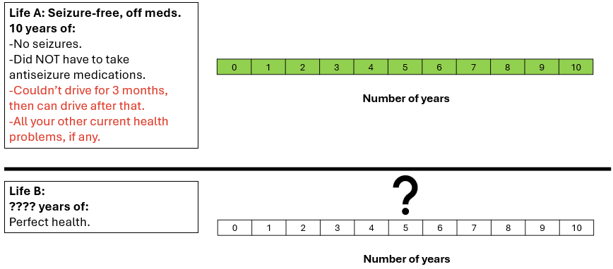

_____ years in Life B would seem about equal to 10 years in Life A.

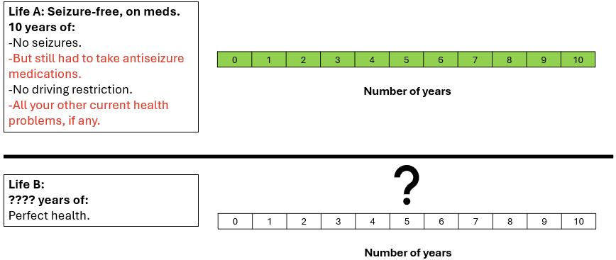
_____ years in Life B would seem about equal to 10 years in Life A.

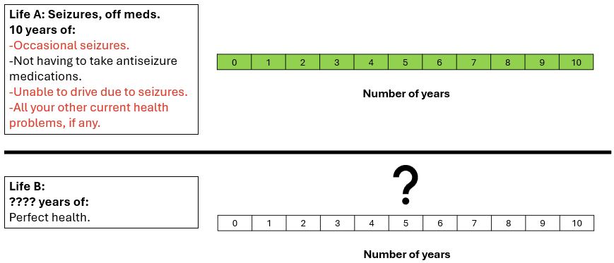_____ years in Life B would seem about equal to 10 years in Life A.

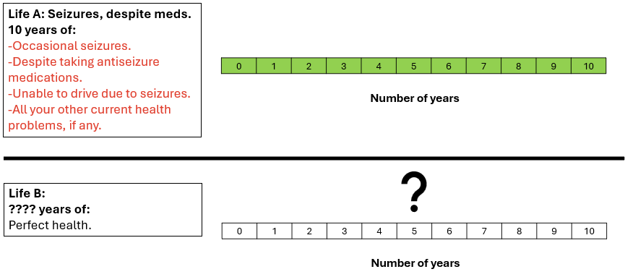_____ years in Life B would seem about equal to 10 years in Life A.

Here are some final questions about you, then we will be done.

- Do you have a current driver’s license?
  - Yes
  - No
- Do you currently work?
  - Yes
  - No
- Are you a caregiver, such as for a child or aging family member?
  - Yes
  - No
- How would you rate your health?
- Excellent
- Very good
- Good
- Fair
- Poor
- What is your highest level of education?
- Less than high school
- High school
- Bachelor’s degree
- Predoctoral graduate degree (e.g., master’s)
- Doctoral degree (e.g., MD, PhD)
- Do you need help bathing or dressing yourself?
  - Yes
  - No
- Do you need help laying out and taking your medications?
  - Yes
  - No
- Do you live by yourself?
  - Yes
  - No
- Would someone be available to help you with daily activities if you needed a caregiver due to medical problems?
  - Yes
  - No

- How hard is it for you to pay for basics like food, housing, medical care, etc.?
  - Very hard
  - Somewhat hard
  - Not hard at all
- When it’s not clear whether healthcare is necessary, what type of person are you?

I strongly lean towards waiting and seeing. | I lean towards waiting and seeing. |  |  |  | I somewhat lean towards waiting and seeing. |  |  |  | I somewhat lean towards taking action. |  |  |  | I lean towards taking action. |  | I strongly lean towards taking action.
1 | 2 |  |  |  | 3 |  |  |  | 4 |  |  |  | 5 |  | 6

- Are you generally a person who is…

…not at all willing to take risks. |  |  |  |  |  |  |  |  |  |  |  |  |  |  |  |  |  | …very willing to take risks.
0 | 1 |  | 2 | 3 |  |  | 4 |  |  | 5 |  |  | 6 |  |  | 7 |  |  | 8 |  | 9 |  | 10

- What do you think the chance of another seizure might be in the next year if you didn’t take any antiseizure medications?
________ [a number between 0% - 100%]

Thank you! The survey is now complete.

